Guide to the Palm based Bidata (The Beekeeper’s Assistant) with scan support

Version 3.0.0.1
Just a remark! Those in this guide mentioned facilities, except from the scanning possibility, is also available in the PC Bidata.
Please remember that you do not need to have a scanner. The palm based Bidata both runs on a handheld with scanner and without scanner, only limitation is that it must be with a version less than palm OS 5. I can’t test it on this, so I do not know if it works on a version 5 OS or not.

This is the Palm main screen. The buttons placed here perform the following actions:

The clear button clears all data on the palm , means that the PC bidata replaces the palm bidata data files with its own without first uploading the palm databases to the PC when performing a hotsync.
- The Honey button moves to the Honey Harvest screen.
- The Next button moves to the Main Selection screen.
- By using a palm based scanner the following actions are taken:
- Scanning a super brings up the Honey Harvest screen.
- Scanning a hive barcode brings up the Select Menu screen.

When a scanning of Hive barcode, the correct hive is selected. If the Hive is not present then it will be created and you will be brought to the Select Menu screen. If you are brought to the Select Menu from this screen, then you can Scrap the BOX by scanning a Zero bar code. Scrapping a hive box can be useful if you transfer it to the Dump, or you otherwise are getting rid of it e.g. you are selling it.

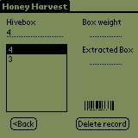
This is the Honey harvest screen. The Hive box edit shows the selected box number you can edit. This number the number you click in the list. The box weight edit field will be the full super weight, while the extracted box edit field will be the weight of the extracted box. You can walk through records by clicking the list or by using the palm up/down button. If you enter this screen and no boxes are shown then you can’t manually enter data. To be able to manually enter data you must either scan a box or have boxes added in add or remove box screen marked as honey boxes.

When scanning a Hive box the correct record will be selected /or added to the list. The list shows the Box number of scanned Box.

The scan support allows you to scan the honey box and then manually enter the weight of full/extracted honey super.
The new and Delete record buttons allow you to manually add and/or delete a record if you are using this facility without a scanner. There will be a new honey palm software edition available later allowing to use a combination of scanner and electronic weight in combination with the PC bidata.

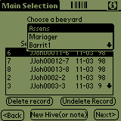
This is the Main Selection Screen. The buttons here perform the following actions:
- The Dropdown allows you to select an Apiary.
- The list shows the hives located in the selected Apiary.
- The new Hive button allows you to create a new hive by bringing up the New Beehive screen.
- The next button brings you to the Select Menu screen, where data editing takes place
- The Delete record button delete the selected hive
- The Undelete Record button allows you to restore deleted hives.
Scanning a Hive barcode here will bring you to the Select Menu with correct hive selected.

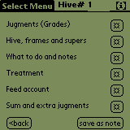
This is the Select Menu and in fact is the screen that gives access to the different data you want to archive. The buttons here perform the following actions:
- Judgment’s (Grades) button brings you to the Disease and Judgments screen
- Hive, frames and supers button brings up the Hive, frames and supers screen
- What to do and notes button brings you to the Notes to the Hive screen.
- Treatment button brings up the Disease and Control screen.
- Feed account button bring up the feeding screen.
- Sum and extra judgments button brings up the sum and extra judgments screen
- The save as note button marks the record as a new note. If this is not used the record is treated as just an update of the note.
- The Back button brings you back to the form that called this form.
Scanning a Box barcode here will either add or remove the super from the database.
Adding a box brings you to the Super selection screen
The removing of the super places it in a pile of unused boxes. Special here: If a zero based barcode is scanned then the box will be scrapped and total be removed from the database.

This is an expanded screen, which gives access to tied supers to a hive and also to add supers from a pile of supers.
The buttons perform the following:

- Opens Hive, Brood and Combs where single frames can be added.
- Add/remove boxes to and from a hive brings you to the Add or remove box screen
- Add boxes to a hive from a pile of boxes. This brings you to the Free supers form
- Edit box type brings you to Select Box to edit/modify
- Back to Select Menu.

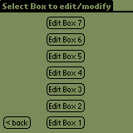
On this screen you can modify the boxes added to the hive. The buttons visible will be those boxes you have added to the hive. That means that if you have only box 1 and box 2 added only Edit box 1 and Edit Box 2 will be visible. The screen shown indicates that all possible seven boxes have been added to the hive.

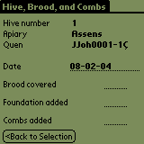
This screen is mainly for manipulation of single frames.
Hive number. Shows the hive in play.
Apiary shows the apiary where the hive is located.
Queen shows the queen in the hive.
Date is the actual date.
Brood covered is meant for entering the size of the brood.
Foundation added are frames with un built wax.
Combs added are drawn frames, such as extracted honeycombs.

Back to selection brings you back to Hive, frames and supers

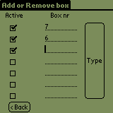
This screen is where you manually tie a Box to a hive or remove it from hive!

The rules for this screen are:
- Check the box you want to add.
- Enter the hive box number as a plain digit. The type button will show up.
- Click the type button to move to the Super selection screen where you can enter extra data for the hive box.
If you uncheck a box here it will be added to the box pile and be removed from the hive, but the hive number will be preserved until reuse on another hive. This means that the hive box can be followed in case of disease inspection and the like. The hive boxes that have been in use for a hive can then be filtered in the PC bidata.
The back button takes you back to the Hive, frames and supers.

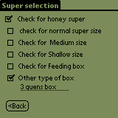
This screen gives the possibility to enter characteristic data for the hive box.
Other type of box gives you the possibility to make a short note of the type of box.

The <back button returns you to the calling screen.

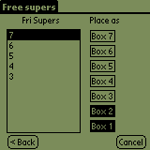
This screen allows you to add supers from a pile of idle supers. The screen shows the possible places that boxes can be added as un-highlighted. The highlighted boxes are showing those already in use.

To add a hive box:

Click one of the free supers in the list then click the place to add it to.

The cancel button clears your selections
The back button brings you back to the Hive, frames and supers screen.

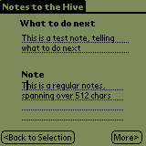
The notes screen is accessed from the Select Menu and gives you the possibility to enter textual notes to the hive. I think it is important to at least fill out the What to do next note, because it gives the ability to plan the next operation for the hive when you visit the apiary. This can be ordering a new queen, harvesting honey supers and other important tasks.

The note is a big note for entering other information’s about the hive and the more button gives you additional two big notes available.

The Back to selection button brings you back to the Select Menu.

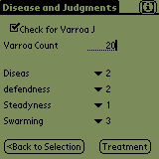
This screen is where you can give information about Varroa and also can judge the hive for the most factors that easily can be used to select the queens out from. The Drop down can be used to select the numbers 1 to 5, where 5 is the best and 1 is the worst.

The buttons here are:
- Back to selection brings you back to the Select Menu.
- The Treatment button moves you to the Disease and Control form.

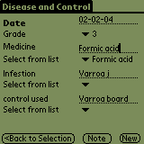
This is the Form where you can enter data about treatment and medicine.

The buttons do the following:

- Back to selection brings you back to the Select Menu
- Note button opens a screen where you can enter notes concerning this screen.
- New button creates a new record, making it possible to have more notes about the hive around the diseases.

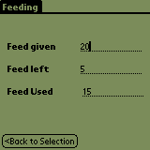
This screen is accessed from the Select Menu screen and is meant for keeping track of food consumption. The feed used entry is read only and is calculated from the feed given and feed left entries.

The back to selection button returns you to the Select Menu

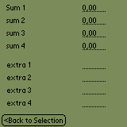
This screen is a for use as an extra judgments screen and summary screen. I myself am using this for extra judgments about e.g. Hygienic bees, and other qualities as well.

the summary I use as a count for queen cells created, Queens transferred to the mating Apiary, queens mated, and queens taken into use (either sold, used in own apiaries , given away or scrapped). But they can be used for other purposes if you have a need.

The back to selection button returns to Select Menu.

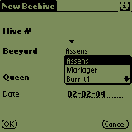
This screen is accessed from the new hive button on the Main selection screen. This can be used if you create new hive in the field by splitting and so.
The hive is a new hive number for this new hive.
The Apiary can be selected from the Apiary list.
The queen must be entered manually. If you make a split with old queen in the new hive you can obtain the queen name from this.
The date is the actual day but can be changed.

The cancel button cancels the establishment of the new hive and returns to the Main selection screen.
The OK button creates the new hive and returns to the Select Menu.

If you are missing some screens then please e-mail me with your suggestion. mailto:sugestions@apimo.dk

Best regards
Jorn Johanesson

